Remote system connectivity using computer vision

FEASIBILITY REPORT

Prepared for

https://hersecondinnings.com/

Prepared by

HSI BATCH 6 Returnship Team

For internal use only

Revision History
Version Number | Description | Date Modified | Author
V1.00 | Remote system connectivity using computer vision |  | Shailaja, Julie, Amita
Contents
1 | Executive Summary | 4
2 | Assessment of Options | 4
3 | Risk Assessment of Viable Options | 5
4 | Recommended Options for Further Analysis | 5

Executive Summary
Automating the process of connecting a remote desktop and accessing it to get data from website or any app like Calculator or Note pad

Assessment of Options
- Technology
Minimum 2 machines with Windows 10 home edition one with VNC Server and other with VNC Client and UIPath community edition.

- Description
Automating the process of connecting a remote desktop and accessing it to get data from website or any app like Calculator or Note pad

- Steps to use
Project Feasibility
Resources Required | Competence | Budget
FTE | 3 | 0
No. of Computers Required | Alteast 2 | 0
Application | VNC Client1 | 0
Application | VNC Server1 | 0
Packages Required | UIPath.ComputerVision.LocalServer | 0
Application | UIPath | 0

Technical Feasibility
- Creating Requirements Spec
- Creating Architecure Design Spec
- Study of various RDP applications
- Remote Desktop Connection - Needs Window Pro edition or
- VNC Viewer - In local system , VNC server - in Remote system
- Establishing Connection between Client and Server
- Steps for connection
  - Open the Vnc viewer in client system and Vnc server in server
  - select the team and select the server name
  - Enter the password and click ok
  - Connection will be established
- Study of UI Path CV
- Computer Vision Activities are mainly used t to automate virtual desktop environments without the need of selectors
- Creating UI Path work flow
- Unit testing
- Exception and Error Handling
- Functional Testing
- Demo preparation

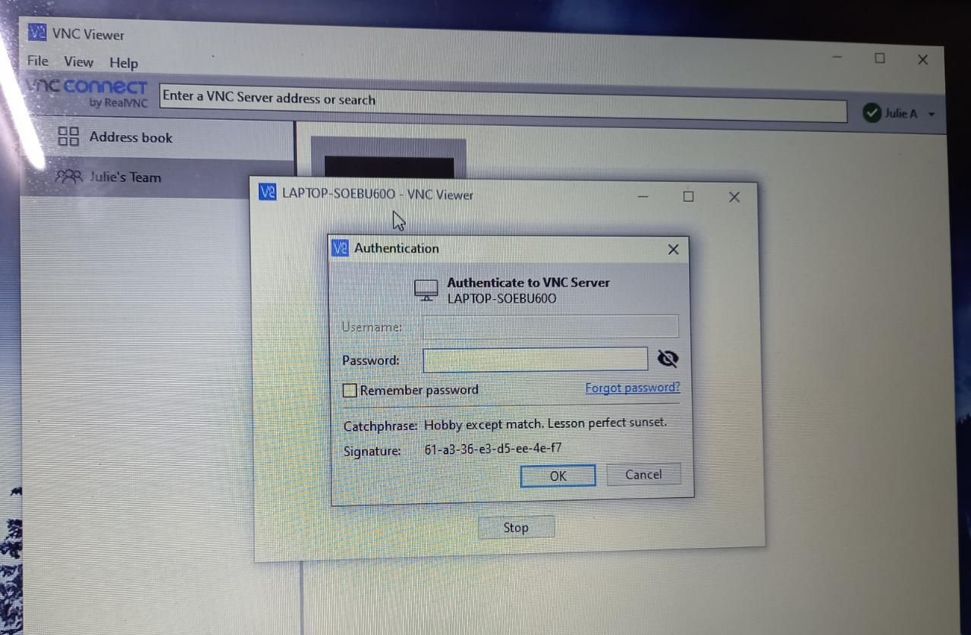

- Problems addressed in project
RDP is done through VNC

- Issues encountered during integration to project
Cannot use Windows RDP as it is available only on Windows Pro

- Pros and Cons
Pros : Manually accessing another desktop to get data is being solved using this automation.
AI Computer Vision eliminates the reliance on selectors, while still maintaining familiar workflows for RPA developers. With an increase in visible screen elements, more automations are possible.
Cons : May face connectivity issue while connecting to the remote machine.
Computer Vision is ultimately based on image recognition, and with a locked screen it is not possible (there is no image to recognize).

Risk Assessment of Viable Options
Data may also be stored on UIPath cloud .

Mitigation Plan
Data Encryption and decryption during data processing should be done.

Recommended Options for Further Analysis
- Accessing the remote desktop to get data from multiple applications.
- Sending emails depending on data scraping to concerned recipients.

